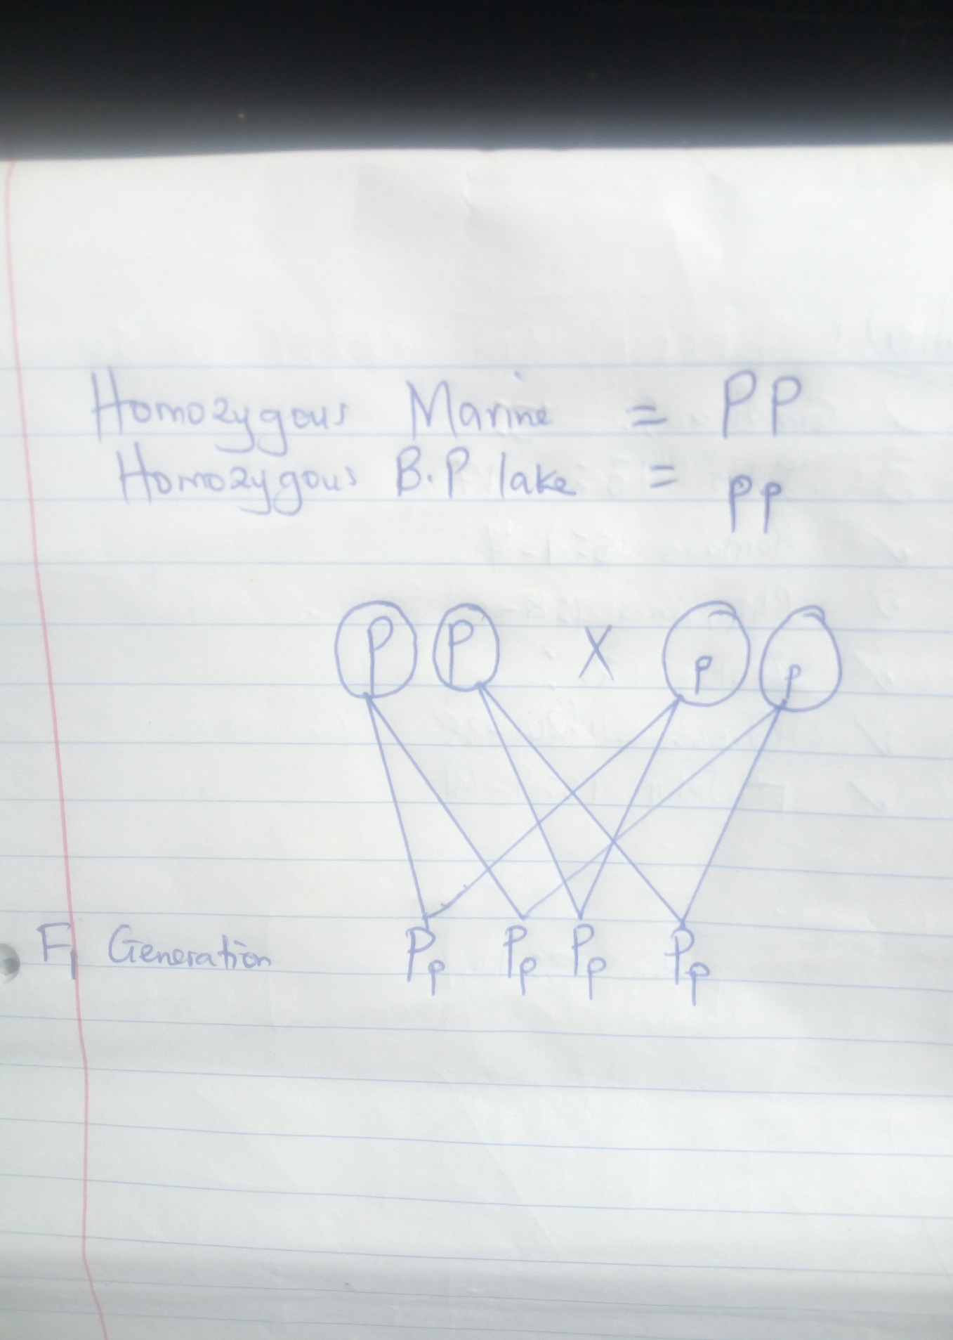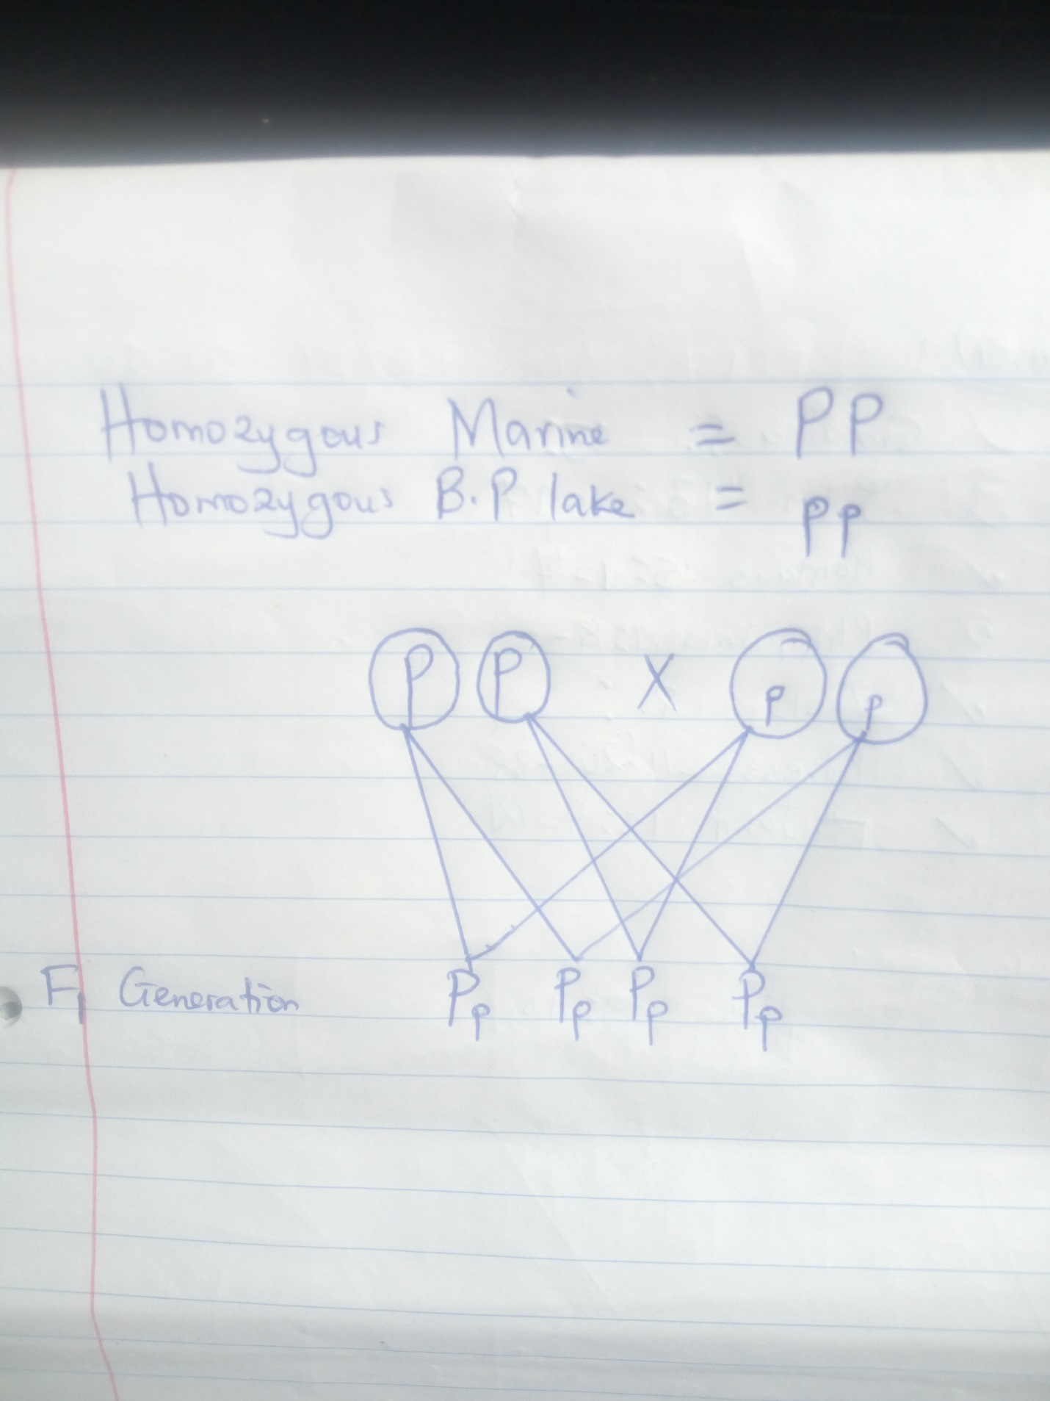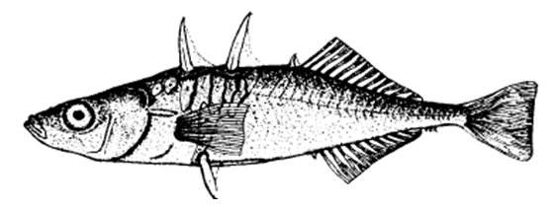
- Inheritance in the stickleback fish

Procedure Watch the film entitled The Making of the Fittest: Evolving Switches, Evolving Bodies https://www.youtube.com/watch?v=Pv4Ca-f4W9Q&feature=youtu.be
Watch to minute 6:10.

1. Based on what you learned in the film, what are the phenotypes of the stickleback fish?
Indicate your choice with a check mark.

Marine fish _x_ pelvic spines present __ pelvic spines absent
Bear Paw Lake fish __ pelvic spines present _x_ pelvic spines absent

- Explain the importance of the marine stickleback fish adaptation to the survival of the species.
Marine stickleback fish have pelvic spines and lateral plates as armors. These are used as shields to protect them from the many preys in marine water, and by so doing, the adaptation helps them fit in that kind of environment, and increase chances of survival. Additionally, reproductive success is advanced.

- Why would the adaptation in question 2 reduce fitness in fresh water sticklebacks? Explain
In freshwater, there is less predation from predatory fish and birds, and the reduced armor features pose a growth advantage in juvenile fresh water stickleback.

- How many pairs of chromosomes are found in the nucleus of a stickleback fish cell? (you will see the diagram in the video).
The pairs of chromosomes are 21 since the total number of chromosomes is 42.

- If we start with the assumption that the presence of pelvic spines is controlled by a dominant gene with two alleles, how would you denote the genotype of two homozygous parents?
Marine ___PP________ Bear Paw Lake __pp_________

- A homozygous marine is crossed with a Bear Paw Lake stickleback. What are the expected offspring (the F1 generation)? Show your work below or on separate page.

Pp | Pp
Pp | Pp

(Working is shown at the end of the document)

- Cross two of the F₁ fish. What are expected phenotypes and what is the ratio of phenotypes in the second filial (F₂) generation? Show work.
PP | Pp
Pp | pp

Spikes phenotype: no spikes phenotype = 3:1

(Working is shown at the end of the document)

- If there are 100 offspring in the F2 generation, approximately how many fish do you expect to have pelvic spines and how many to lack pelvic spines?

75 offsprings have pelvic spines while 25 have no pelvic spines.

(Working is shown at the end of the document)

- View the pdf file https://www.biointeractive.org/sites/default/files/Stickleback_F1_Cards.pdf
The set (16 cards) represents the first filial (F₁) generation of the cross between the homozygous marine fish and homozygous Bear Lake fish in question 6.
Sort the 16 cards into two separate groups: fish with pelvic spines and without spines. Add your data to the table below.

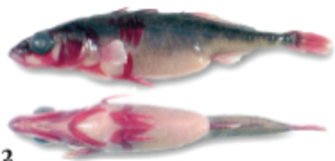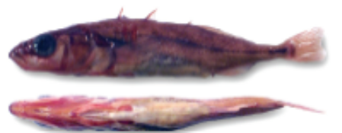
Fish with pelvic spine Fish lacking pelvic spine
Table 1. Results of a Cross Between Marine and Bear Paw Lake Stickleback

Generation | Fish with pelvic spines | Fish without pelvic spines
P | 1 | 1
F₁ | 16 | 0
F₂ | 27 | 13

- Repeat with the F₂ set of cards. There are 40 cards in this set. https://www.biointeractive.org/sites/default/files/Stickleback_F2_Cards.pdf Count and record in Table 1.

- What is the ratio of fish with pelvic spines to fish without pelvic spines in the F₂ generation?

3:1

- Inheritance in Corn
Corn is often used as a model organism in genetics. Each kernel of corn on an ear is a separate offspring. View the offspring (kernels) on the ear of corn below.
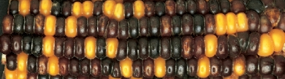

- Count the yellow and purple kernals. Determine the approximate ratio of the 2 phenotypes, (there are only 2 colors, choose either purple of yellow).
3:1 that is, Purple:Yellow

- Based on this ratio, what are the genotypes of the parents?

Pp and Pp

- Dominance, Incomplete Dominance, and Two-Gene Inheritance
Ball pythons exhibit many color and pattern combinations. Some varieties, or morphs, originate in wild snake populations from sub-Saharan Africa while others have been bred in captivity. They are non-venomous and make excellent pets as they are gentle and grow to about 3 feet in length. A wildtype snake is one that exhibits the usual color and markings of a snake in its natural environment.

Artificial selection has resulted in diverse and interesting skin coloration and patterning in the ball python. Some alleles that determine color and pattern show complete dominance over recessive alleles. Other alleles have an incomplete dominance relationship in which neither allele is dominant over the other. In this case, the phenotype of a heterozygote is intermediate to that of the homozygous dominant or recessive organism.

Allele keys
A = normal color Albinos snakes are amelanistic, with no dark pigments,
a = albino leaving a bright yellow and white snake with pink/red eyes.

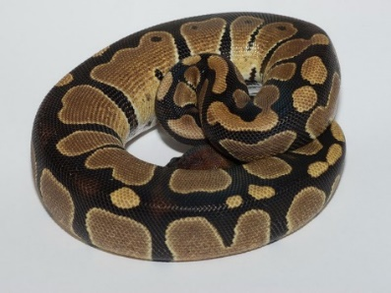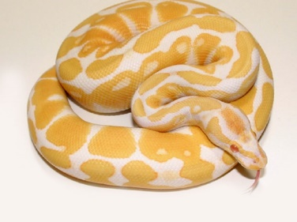
Wildtype snake is AA or Aa Albino snake is aa

N = normal distribution of color A piebald snake has a pattern of pigmented spots on an
n = piebald unpigmented (white) background.
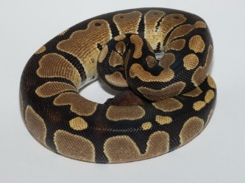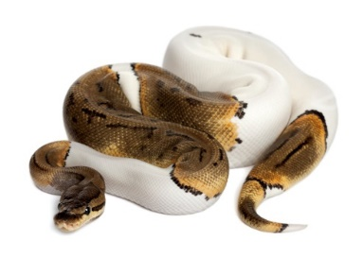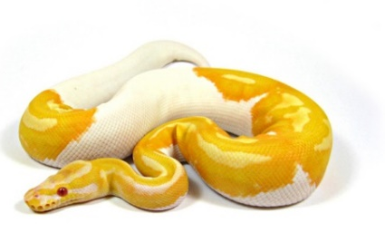
This snake is piebald and albino

S = spider pattern The dominant allele causes the darker color to be
s = normal pattern restricted to vertical stripes that resemble spider legs.
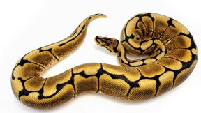
The spider pattern is dominant The wildtype pattern is recessive

X = pinstripe pattern the dominant allele causes the darker color to be restricted
x = normal pattern to very thin vertical stripes.
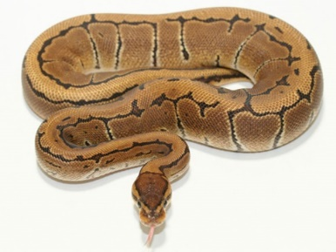
The pinstripe pattern is dominant over the wildtype pattern

P = normal intensity of color Incomplete dominance
P’ = light color Snakes with the PP genotype have normal color intensity.
The PP’ genotype results in a lighter color called pastel.
Super pastels are very light in color and are P’P’.
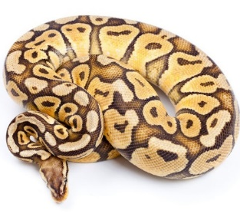 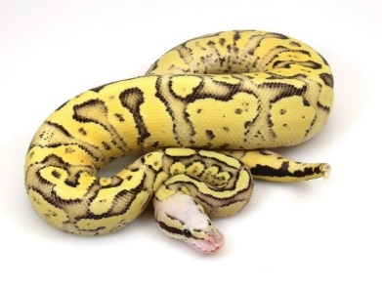 Wildtype PO Pastel (PP’) Superpastel (P’P’)
A. One gene inheritance
14. Cross a homozygous wildtype snake to an albino snake. What is the expected ratio of phenotypes in the offspring?

Aa | Aa
Aa | Aa

Wildtype: albino, 4:0 phenotypes. All the offspring will have normal color of the wildtype snake.
15. Cross a heterozygous pinstripe snake with a non-pinstripe snake. What is the expected ratio of phenotypes in the offspring?
Xx | xx
Xx | xx

\Pinstripe: non-pinstripe =2:2, (1:1) phenotypes

16. Incomplete dominance. Cross two pastel snakes. What is the expected ratio of phenotypes in the offspring?
PP | PP’
PP’ | P’P’
1:2:1 that is, 1 normal: 2 pastels: 1superpastel phenotypes
- Two gene inheritance
Cross an albino piebald snake to a snake heterozygous for wildtype color and heterozygous for normal pigment distribution. Show the cross using symbols.
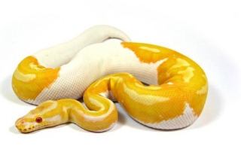 and 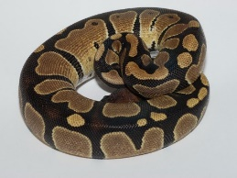

- What is the expected ratio of phenotypes in the offspring?

AAaa | ANaa | AAan | AaNn
NAaa | NNaa | NnAa | NNan
AAna | AaNn | AAnn | AnNn
NAna | NNan | NnNA | NNnn

Phenotypes= 9 normal color and distribution: 7 albino and piebald

- What is the chance of obtaining an albino snake (not piebald) in the offspring?

One chance

- What is the genotype of this snake (in previous question)?

aaNN
- What is the genotype of an albino, piebald snake?

aann

NO. 6
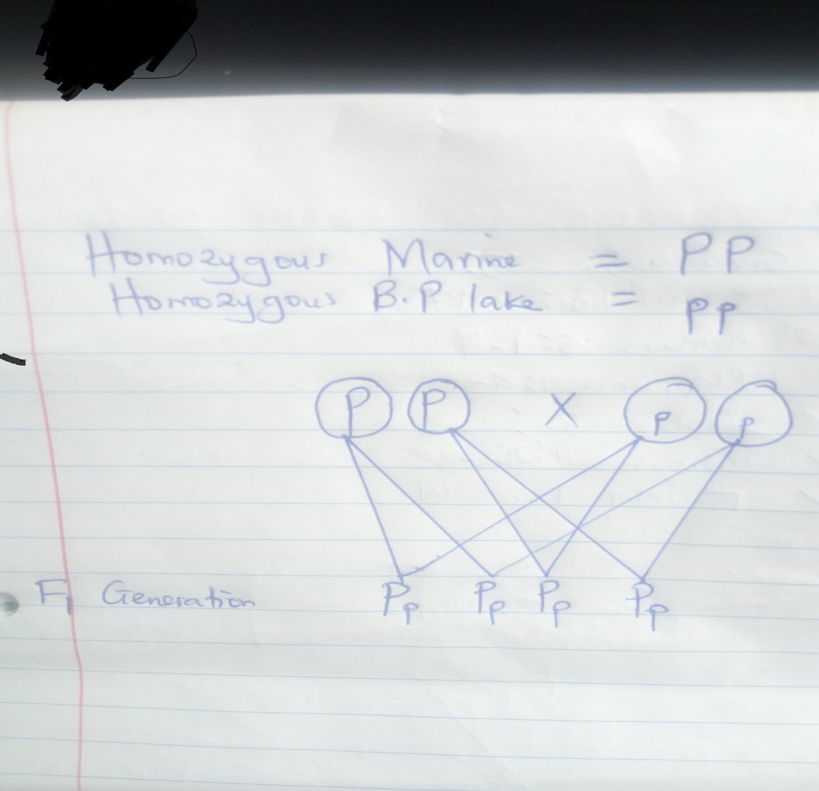

NO.7
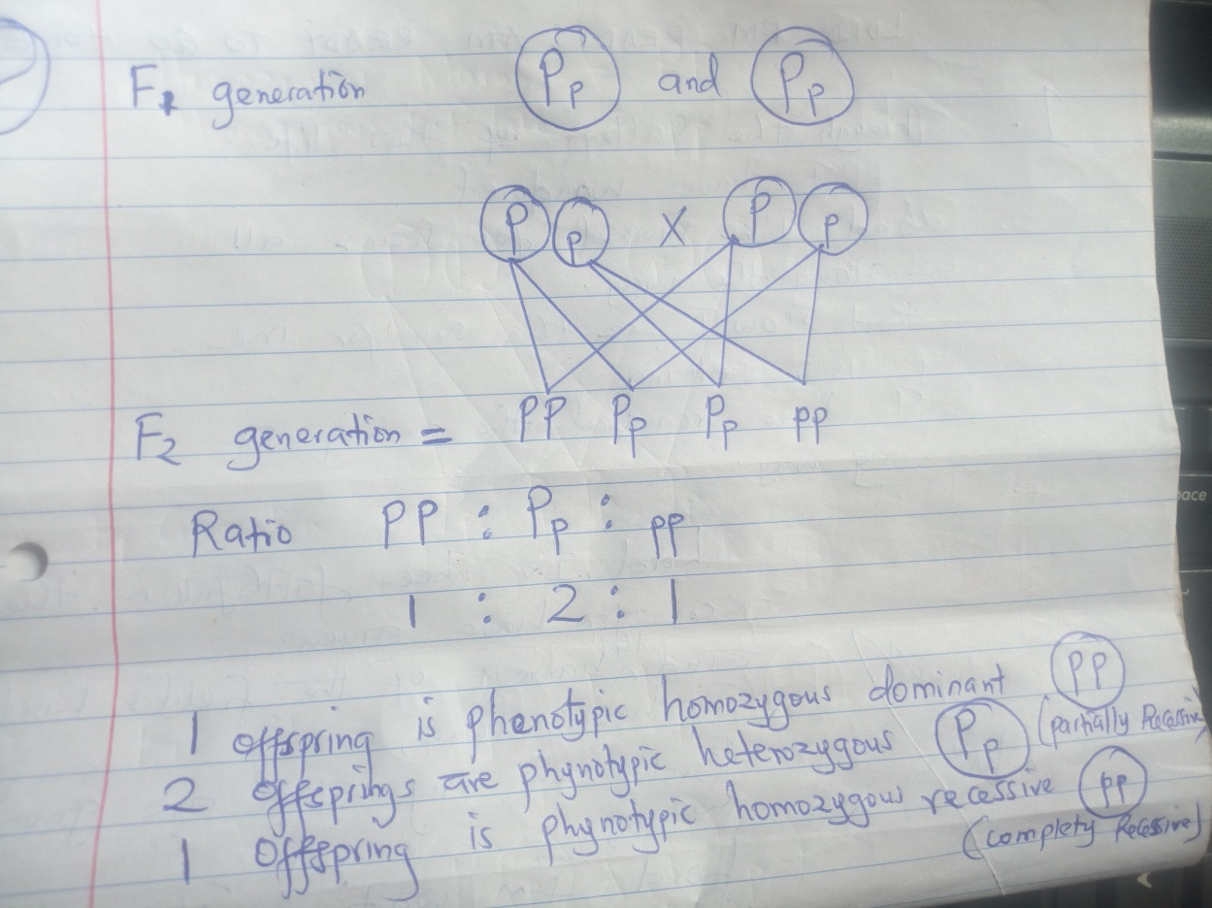

NO. 8
